**World Quant University**

**Professor: Ivan Blanco**

**Alpha Design I**

Nikolas Lippmann Pareschi - [nikolaslippmann@gmail.com](mailto:nikolaslippmann@gmail.com)

**Mini Project 4**

1. Gather the daily high, low, and closing prices for McDonald's stock (ticker symbol MCD) for January 2004 through July 2005 from an appropriate financial website such as Google Finance, Yahoo Finance, Quandl, CityFALCON, or another similar source.

Code:

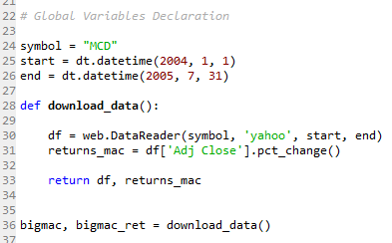

1. Calculate 10-day and 60-day SMAs. Plot these two curves with a bar chart of the stock prices.

Code:

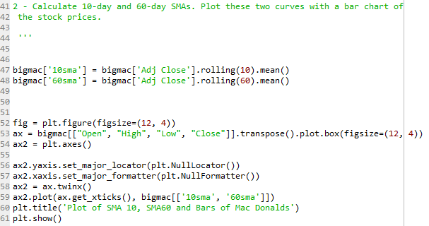

Graph: 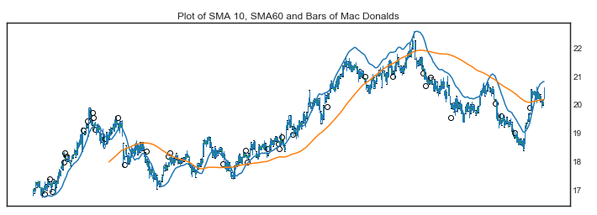

1. Compare and contrast the 10-day and the 60-day SMA.

Code:

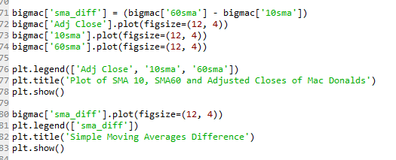

Graphs:

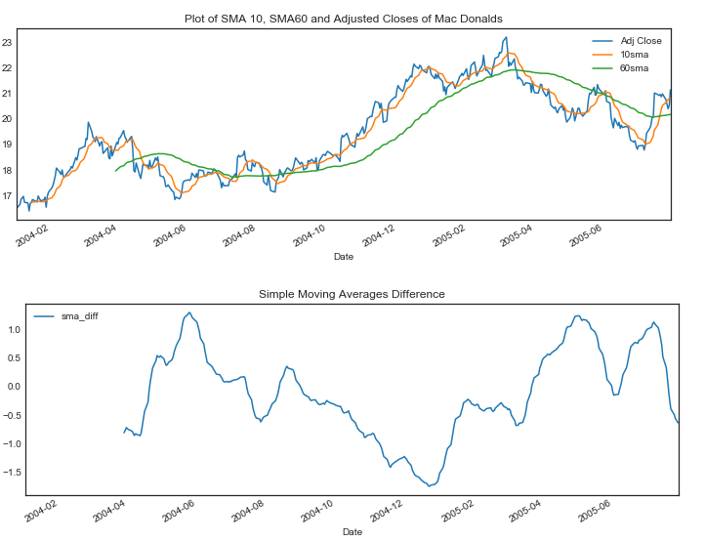

1. Explain the relationship between the market trend and the 60-day SMA during the following periods:

May 2004-October 2004, October 2004-May 2005, May 2005-July 2005

Code:

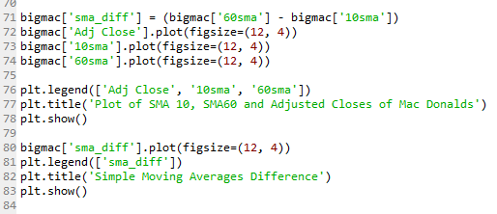

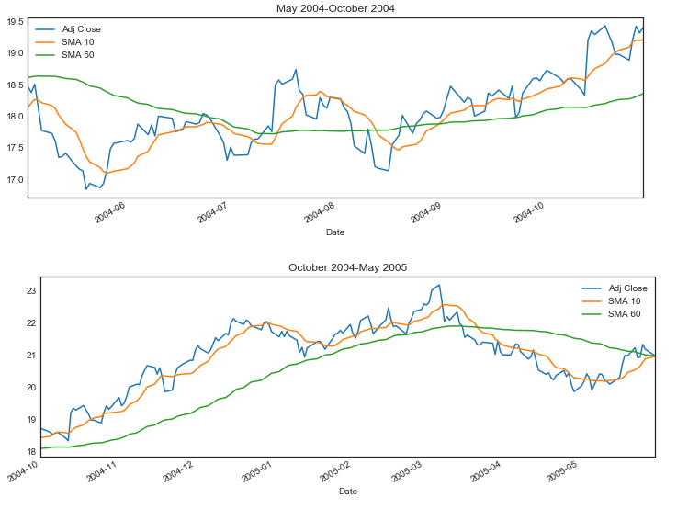

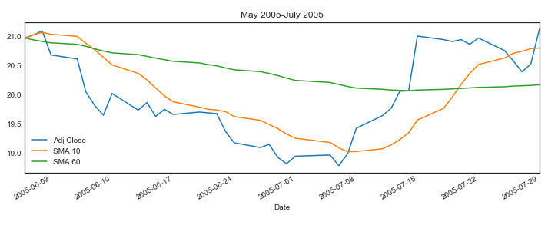

In the first regime, if we followed a trend following system for example that would buy when the close of prices were above the 60 SMA we would clearly have lost money. In that regime the market wast trendless. Maybe we should combine that metric with the derivative (Slope of the SMA) or a Hurst Coefficient. In the second and third graphs the SMA would have pointed correctly the market regime, in the first case a bull market and in the second one a bear market.

1. Draw the moving average oscillator of the price chart.

Code and Graph:

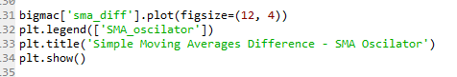

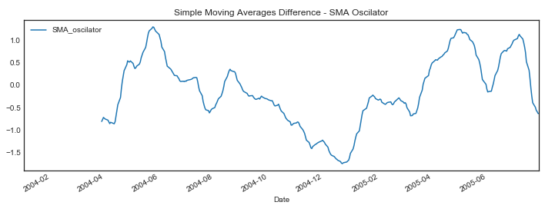

1. Bollinger Band is a band plotted 1.5 standard deviations away from a simple moving average. Calculate the Bollinger bands of 10-day simple moving average for Mac Donald share.
2. Develop a trading strategy based on the relation between price and Bollinger Bands. Graphically represent the risk-return profile of such a trading strategy

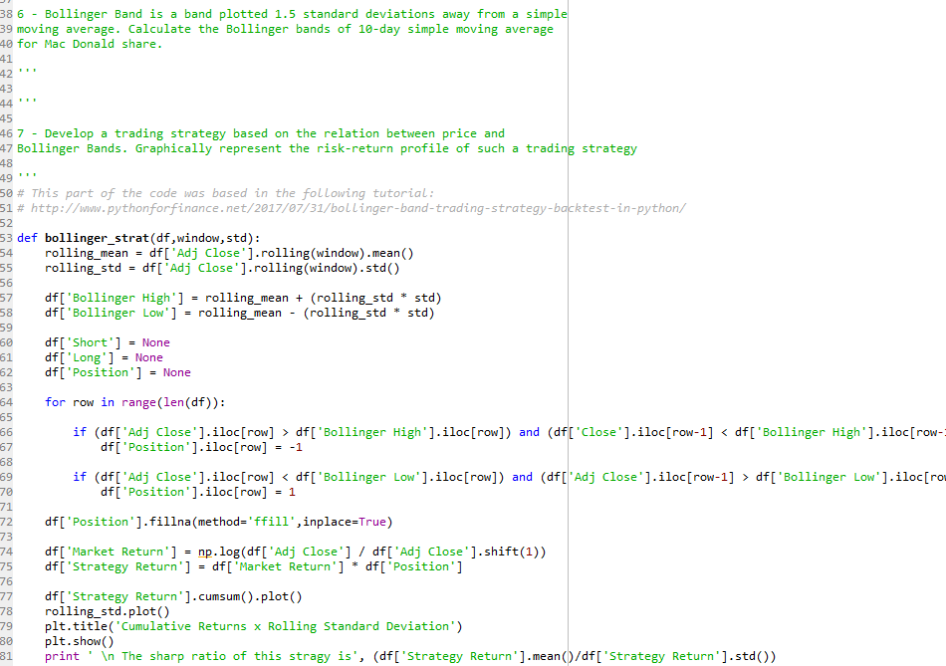

Graph and results:

